|  |  |  |
| --- | --- | --- |
| **LAB 321 Assignment** | **Type:** | **Long Assignment** |
| **Code:** | **J3.L.P0034** |
| **LOC:** | **600** |
| **Slot(s):** | **15** |

**Title:** Musician, Singer & Entertainer

**Background**

### You like music, and you want to share your favorites to every one ?

Complete this assignment to know how to do ☺

Reference site: <http://us-123entertainment.simplesite.com/>

**Program Specifications**

Program a web site to introduce your band, detail functions of this website is described below

**Features:**

This website contains 3 main functions

* Function 1 : Home page : ( see PIC 01)
  + Display introduction entry , calendar
* Function 2 : About me ( PIC 02)
  + Print out information about your band
* Function 3 : Review ( PIC 03)
  + Help user to submit her reviews
* Function 4 : Contact
  + Print out contact information

You do not need to write interface for admin control panel, you can add data manually (use SQL SERVER Management studio).

Note: All data must be load from database, not hard code in page.

***Expectation of User interface:***

Pic 01 : Home Page

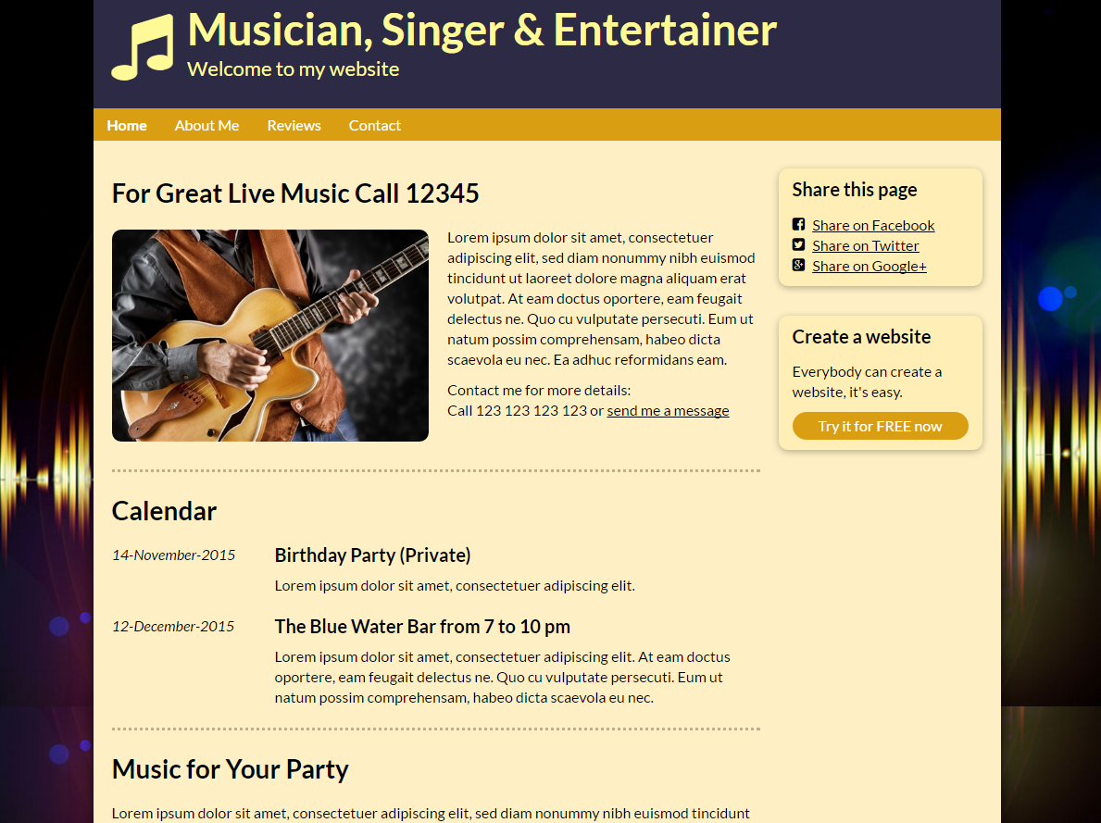

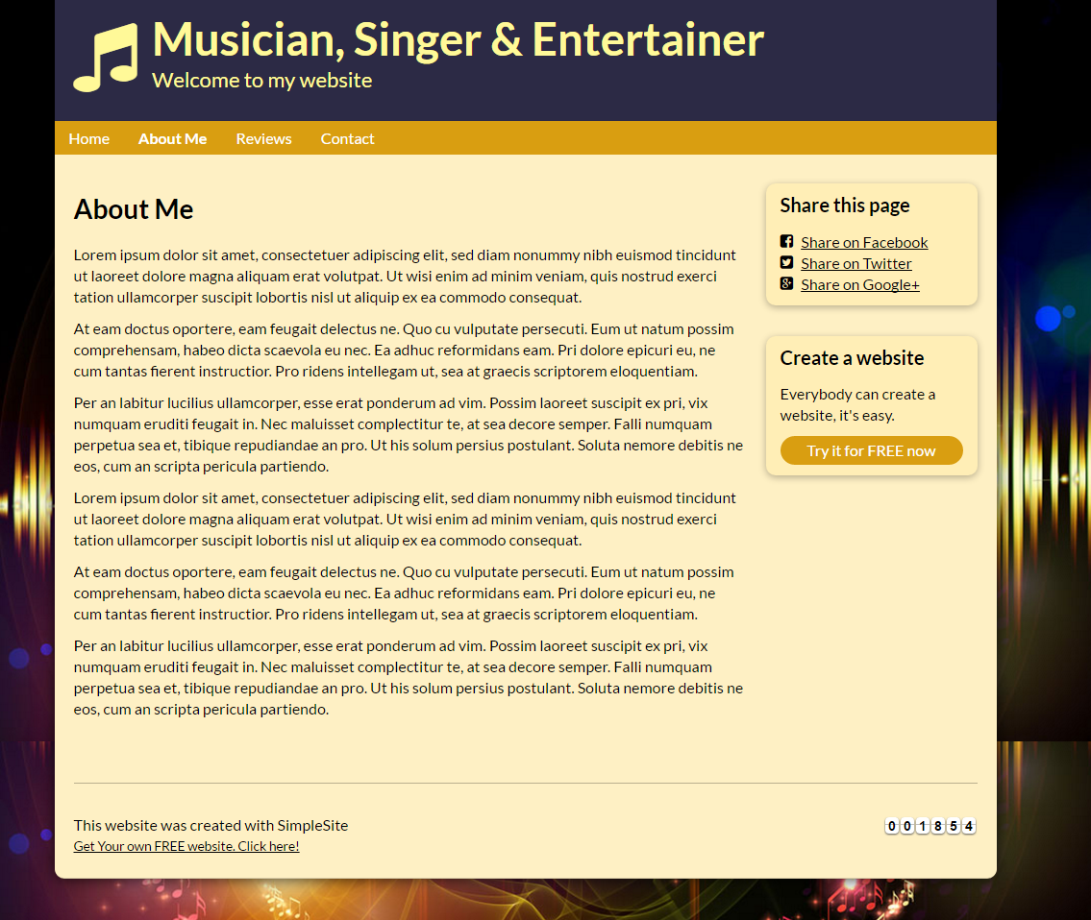

PIC 3 : Contact : allow user to submit message here

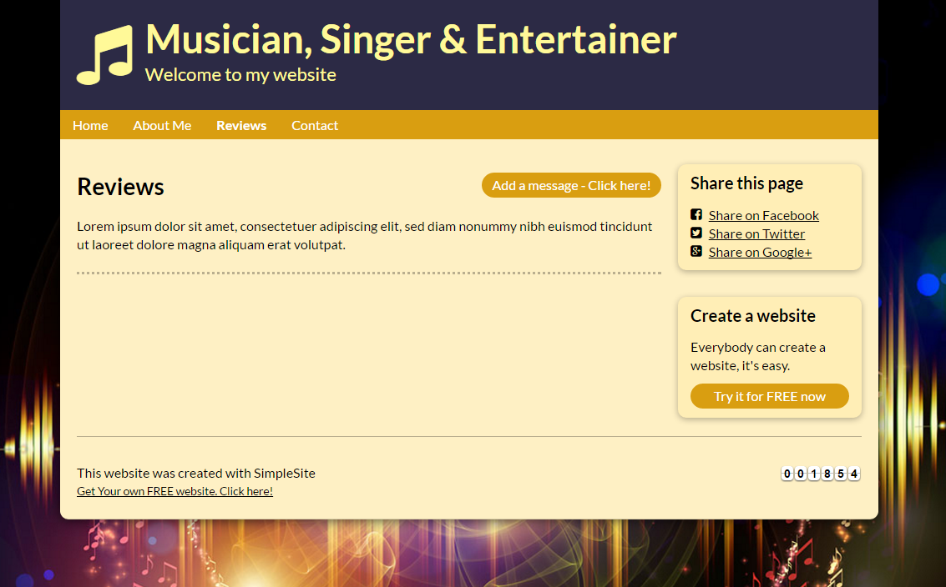

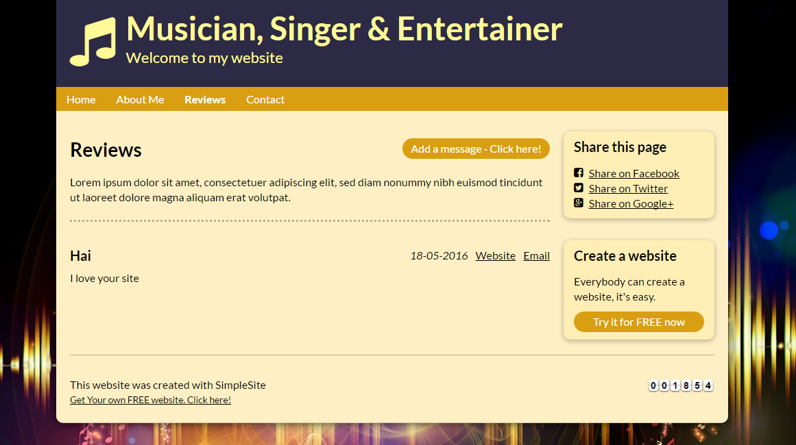

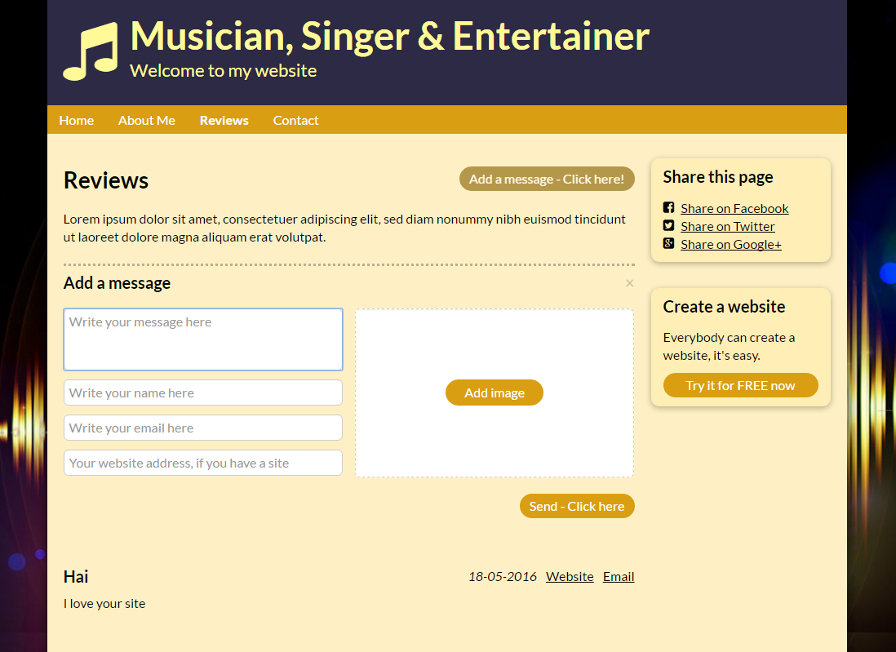

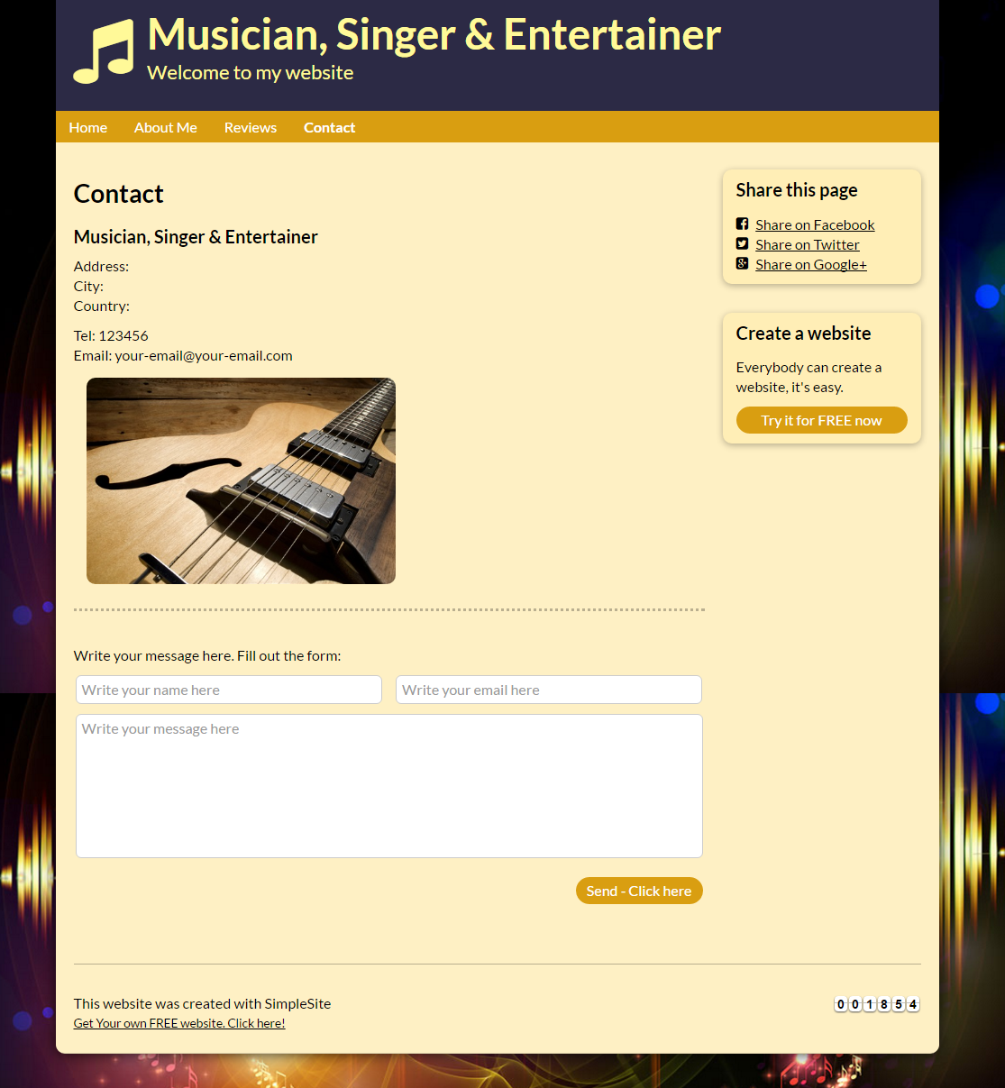

**Guidelines**

* Step 1 : Create web layout
* Step 2 : Create prototype
* Step 3 : Design database base on created prototype
* Step 4 : Code & Test